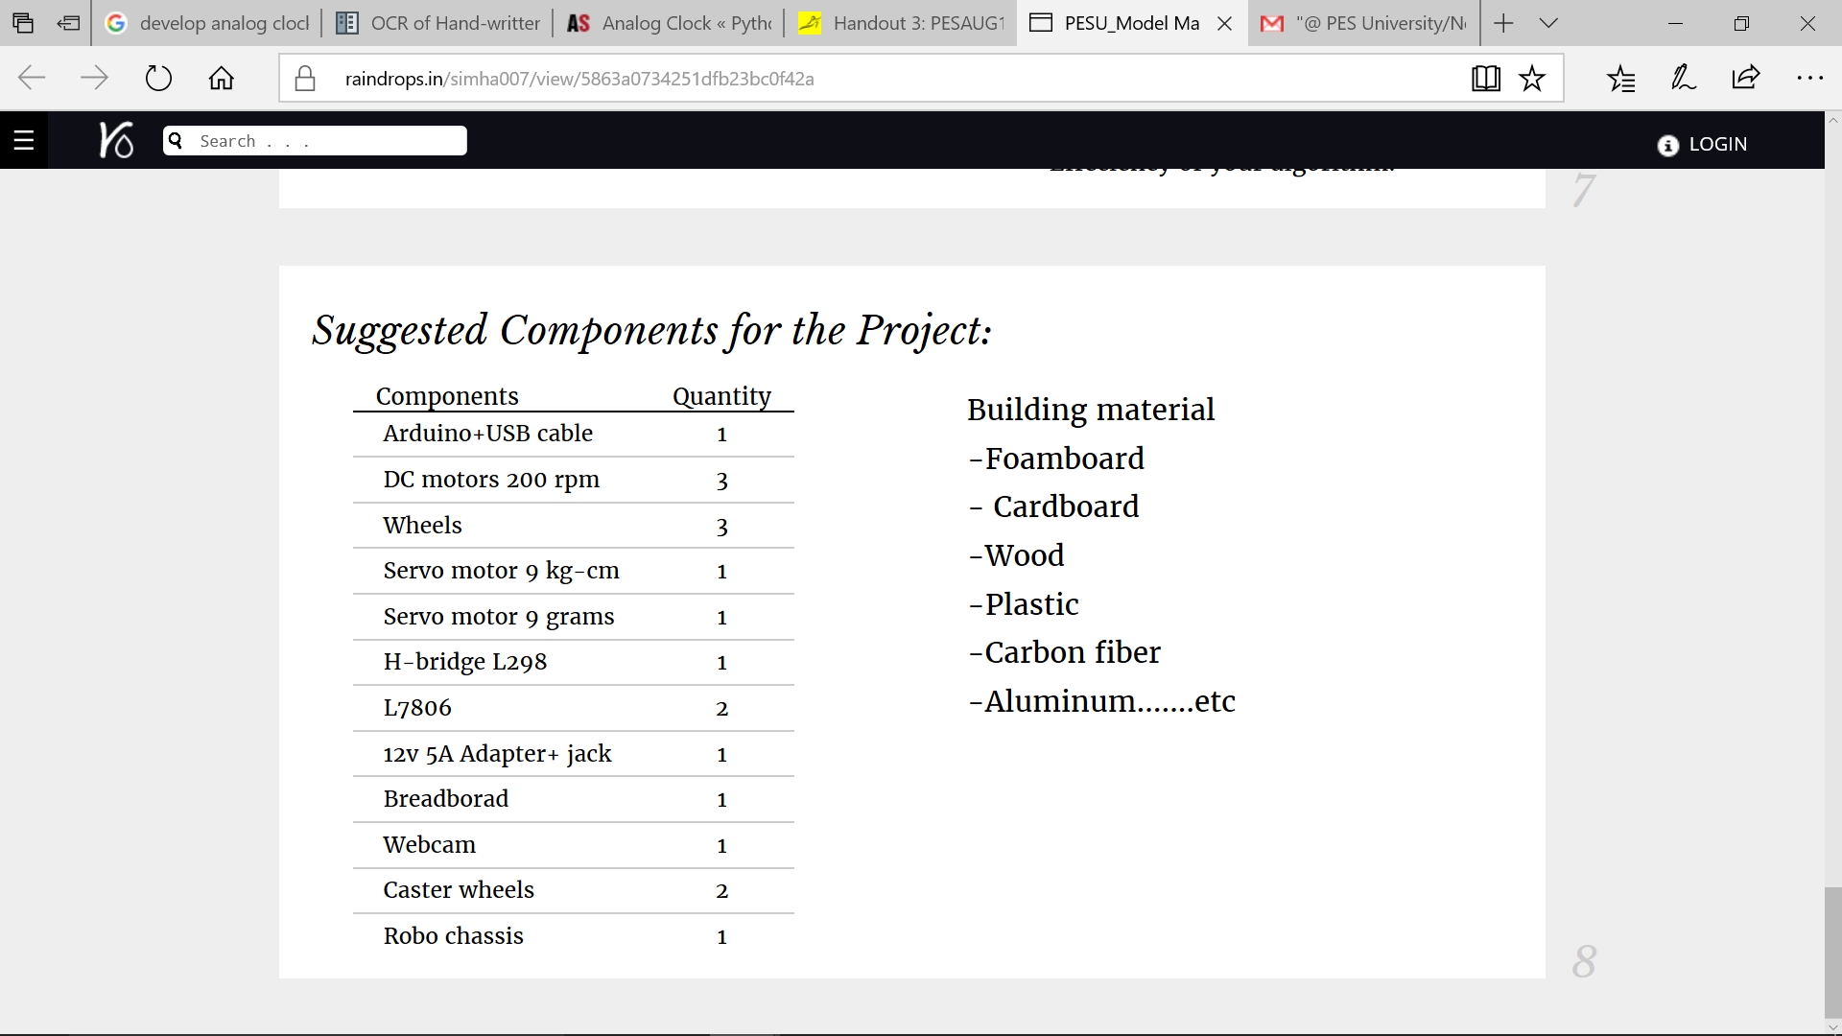

T-cobbler

Male-Female Wires

Industrial grade feviquick

Solder

Nuts and Bolts

Terminals

Materials:

* Balsa Wood

***Bills***